**Detection and Classification of Vehicles**

**Problem Statement**

The advanced digital data infrastructure of deployed surveillance systems enables the development of automated video analysis tools which can be used for traffic surveillance also events can be identified and alarms can be raised before. Vehicle detection and classification system for traffic scenes aims to guide surveillance operators and reduce human resources for observing hundreds of cameras in traffic surveillance which can reduce the rate of road accidents for drivers and also for driverless cars success rate can be increased. Main challenge of surveillance is the limitation of human resources for observing hundreds of cameras. In this research per frame vehicle detection and classification using 3D models which will use the deep learning approach and make use of CNN network are proposed which can be used as a product in real life. The detector will make a use of background estimation to extract motion silhouettes from a video frame. The classifier will use 3D wire frame models and CNN to find the corresponding class label for every silhouette. In this deep neural network tests, S-sharped functions are selected to be activation functions in hidden layers, while the famous back-propagation algorithm is adopted in training process.

**Background**

The classification of vehicles has recently lacked consideration related to detection and is usually performed on a low number of classes. Detection and classification of vehicles uses classification and detection method for the analysis so the main challenge is of selecting a suitable set of features for subsequent classification and detection. Despite the challenges, vehicle detection and classification system still remains an active research area in computer vision in recent years. Numerous approaches have been proposed over these years like the object recognition uses Scale Invariant Feature Transform (SIFT) feature. Face recognition uses Local Binary Patterns (LBP) feature, and the pedestrian detection uses Histogram of Oriented Gradient (HOG) feature .Recent surveys of research in this field shows that approaches like region- based vehicle detection and classification system is proposed, real time system to track and classify vehicles at intersections in urban areas using 3D models, standard Gaussian Mixture Model are also used in this field, feature vector based on silhouette measurements is also used, Kalman filter is also used to track the foreground regions based on the centroids.

**Methodology**

**Step 1: Data collection and dataset preparation**

This will involve collection of data by recording using a camera with auto iris function which keeps the average illumination of the view constant and also i-LIDS dataset is used then the input data is processed into a set of features before becoming suitable inputs for per frame vehicle detection and classification using 3D models.

**Step 2: Developing A 3D Model with CNN for Detection and Classification of Vehicles**

In this step a 3D model with CNN is designed for or per frame vehicle detection and classification. Ground truth of bounding boxes and class labels for vehicles are calculated. Gaussian Mixture Model implementation in the OpenCV library is also used.

**Step 3: Training and experimentation on datasets**

The 3D model per frame vehicle classification and detection model will be trained on the dataset to do vehicle classification and detection accurately and notify.

**Step 4: Deployment and analysis on real life scenario**

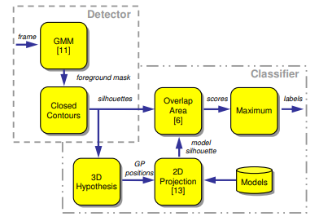

Figure 1 Block diagram of proposed system for classification and detection using 3D model [Buch, Norbert, James Orwell, and Sergio A. Velastin. "Detection and classification of vehicles for urban traffic scenes." (2008): 182-187]

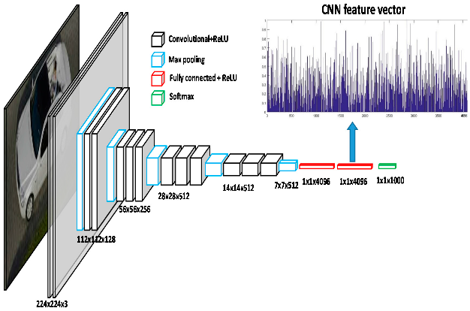

(a)

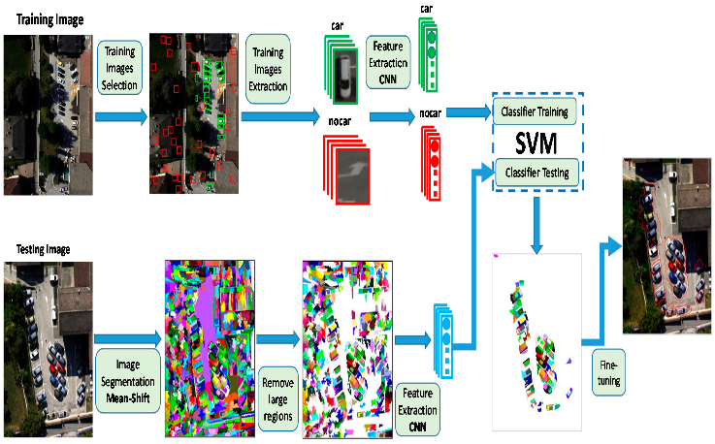

(b)

Figure.2 Block diagram of proposed system for classification and detection using CNN to extract the features[Ammour, Nassim, et al. "Deep learning approach for car detection in UAV imagery." Remote Sensing 9.4 (2017): 312.]

The trained and tested vehicle classification and detection model will be deployed in a real-life scenario to sense traffic& will be leveraged for further improvement in the methodology and will follow the above architecture.

**Experimental Design**

**Dataset**

The i-LIDS dataset is licensed by the UK Home Office for image research institutions and manufacturers (https://www.gov.uk/guidance/imagery-library-for-intelligent-detection-systems) will be used for experimentation and evaluation**.**

**Evaluation Measures**

Measures such as confusion matrix including FP (false positives) and FN (false negatives) for the evaluation of detector and classifier, precision recall and TP (true positive) will be measured and evaluation is done for detection and classification of vehicles. 3D models for matching with closed contours extracted from motion foreground and evaluation on a public dataset

**Software and Hardware Requirements**

Python based Computer Vision and Deep Learning libraries will be exploited for the development and experimentation of the project. Tools such as Anaconda Python and libraries such as Tensorflow, OpenCV and Keras will be utilized for this process. Recordings using a camera with auto iris function will be needed. Training will be conducted on NVIDIA GPUs for training the above proposed system that contains 3D models for detection and classification of vehicles.